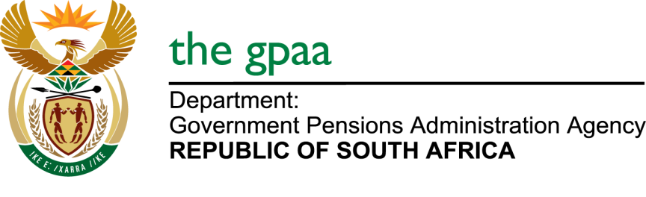

CLOSING DATE: 26 AUGUST 2019
SUPPLY, TRANSPORTATION, RIGGING, INSTALLATION, TESTING, COMMISIONING OF DIESEL GENERATORS CIDB GRADING 4EB/4ME (GPAA 16/2019)
NAME OF BIDDERS

- Multi-Net Systems (Pty) Ltd
- Mosomedi Refrigeration cc
- Leruwaruwa Trading and Projects
- Elroi Trading Enterprise cc
- Diesel Innovations (Pty) Ltd
- Isiziba Projects (Pty) Ltd
- Ampcor Khanyisa (Pty) Ltd
- Lengwati Electrical cc
- Tlops Contracting cc
- Lanzima Electrical Services cc
- Moloko Group Holdings (Pty) Ltd
- Matase Industrial Solutions (Pty) Ltd
- Globalspek Group
- Nzwalo Investments (Pty) Ltd T/A Lumacon Air Conditioning
- Nextec Industrial Technologies (Pty) Ltd
- Excellent Electrical Projects
- Cool Breeze Air-conditioning and Refrigeration
- SBM Electro Mechanic Group (Pty) Ltd
- Nqobisizwe Construction and Projects (Pty) Ltd
- Tokologo Technical Assignments cc
- Veritas Engineering and Project Management Consultants
- Africa Related Mo Electrical Engineering cc

